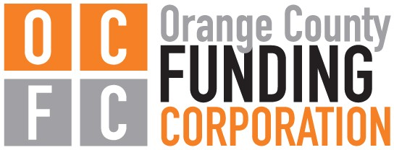

Michael Torelli, Chairman • Dean Tamburri, Vice Chairman • Vincent Odock, Secretary • James Rinaldi, Board Member
Susan Walski, Board Member • Marc Greene, Board Member • Giovanni Palladino, Board Member
William Fioravanti, Chief Executive Officer • Susan R. Katzoff, General Counsel • Christopher C. Canada, Bond Counsel

REVISED Agenda
PLEASE TAKE NOTICE, The Orange County Funding Corporation will hold a regularly scheduled meeting on October 19, 2022, at 5:30 p.m. at the Orange County Government Center, 255 Main St., Goshen NY in the First Floor Community Room to consider and/or act upon the following:

Order of Business

- Call Meeting to Order
- Pledge of Allegiance
- Roll Call
- Introduction of Bond Counsel – Christoper Cananda, Hodgson Russ, LLP
- Minutes
  - Approval of the minutes from the September 21st, 2022 BOD meeting
- Committee Meetings - Finance Committee Report
  - September Financial Reports
  - COVID-19 Resiliency Loan update
  - September/October payables
- New Business
- Approval of PKF O’Connor Davies for 2022 Annual Audit
- Vote on Resolution for Re-issue of Bonds (Sentinel Realty of Port Jervis)
- Vote on Committee Assignments
- Vote on 2026 Draft Budget
- Adjournment

To watch the livestream, please visit our website: www.ocnyida.com

Dated: October 13, 2022 By: William Fioravanti - Chief Executive Officer

Orange County Funding Corporation
4 Crotty Lane, Suite 100 • New Windsor, NY 12553
Phone: (845) 234-4192 • Fax: (845) 220-2228 • Email: business@ocnyida.com

