Mary Ellen Rogulski, Chairman • Edward A. Diana, Vice Chairman • James DiSalvo • Second Vice Chairman Stephen Brescia, Secretary • Michael Gaydos, Assistant Secretary • Robert J. Schreibeis, Sr., • John McCarey • Laurie Villasuso, Chief Executive Officer •Vincent Cozzolino, Managing Director • Kevin Dowd, Attorney •Russell E. Gaenzle, Harris Beach • Joel Kleiman, Chief Financial Officer

Date: From: RE:
February 27, 2019 Laurie Villasuso Next Meeting Date

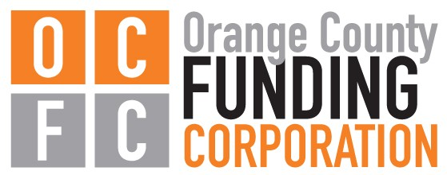
OCFC Board Meeting Notice

The next Board of Directors meeting of the Orange County Funding Corporation is:

Thursday, March 12, 2020 immediately following the 2:00pm regular meeting of the Orange County IDA

The Accelerator
4 Crotty Lane, Suite 100 New Windsor, NY 12553

Orange County Funding Corporation
4 Crotty Lane, Suite 100 • New Windsor, NY 12553
Phone: (845) 234-4192 • Fax: (845) 220-2228 • Email: business@ocnyida.com

